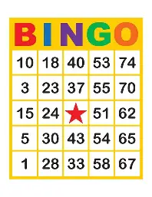

Join us on the 3rd Saturday of each month at the Phippsburg Sportsmen’s Association for a free afternoon of snacks, prizes, and friendly competition!
This event is open to all ages, though we do ask that children be accompanied by an adult and have the focus to play along.

