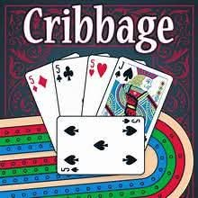

Ready for a little friendly competition? Join us at the Phippsburg Sportsman’s Association on Thursday, May 7th at 6 PM for Cribbage Night!
This is a FREE community event and is open to everyone - whether you're a pro or just learning the ropes, we’d love to have you! It’s the perfect excuse to catch up with friends, meet new neighbors, and enjoy a relaxed evening together.
We’ll have plenty of hot coffee to keep the games going! We’ll also have boards and cards ready, but feel free to bring your own lucky board if you prefer!
Help us spread the word and let’s get a great game going. See you at the board!
If all goes well, we plan on hosting a cribbage night on the 1st and 3rd Thursday of each month, so stay tuned.

